Scriptout EXISTING database mail settings - SQL Server
Find the attached script which will script out your present SQL Server Database Mail Setup and Configuration Scripts.
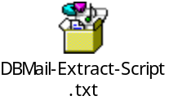
It will give you the script to Drop Settings For DatabaseMail.
We had requirement from the application team to script out DB mail profiles as they are using different database mail profiles in each production DB server.
Note: Tested on SQL 2005, SQL 2008 & SQL 2008 R2.

